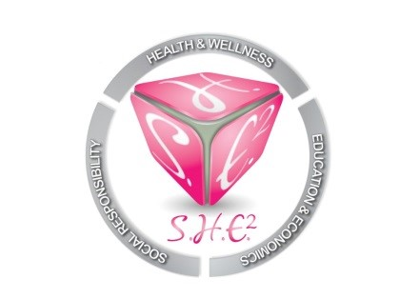
CONFERENCE CALL MINUTES
August 5, 2018
6:00PM-6:45PM
Our mission is to empower and motivate women of all ages and backgrounds in the areas of Social responsibility, Health and wellness, Education and Economics. S.H.E. Squared will provide workshops, seminars, scholarships and community support to individuals and organizations that are either female driven or geared towards the advancement of women.

I.Roll Call
Carlis Lollie, Jeffea Gullett, Yolanda Brown, LaShandra Boddy, Latonia Harrison, Erin Mosely

II. 80’s Rock Brunch
Team will focus efforts on trying to sale (3) more tickets each and will determine on Wednesday, August 8th if the event needs to be canceled.
-Lead:Carlis

III. Boo Bash (Halloween Fundraiser)
Details are pending. Erin Mosely volunteered to lead. Discussed partnering with Black Girls Code. Details will be provided at next meeting.
-Lead: Erin Mosely

IV. Nursing Scholarship Cocktail Gala
S.H.E. Squared is partnering with "Washington-Nixon Nursing Scholarship". Sponsorships from Comerica and HEB are pending. Auction items are still needed. Goal is to raise $10,000 for nursing school scholarships for single moms. Ticket sales goal of 200 tickets.
-Lead:Carlis

V. Christmas Event (Sponsor A Family)
Jeffea Gullett volunteered to lead the Christmas community service event. Details are forthcoming.
-Lead: Jeffea Gullett

V. Closing
-Dues ($25/month-$300/Year)-Bank Financial Statements will be distributed at all in-person meetings effective immediately.
-Review discussion
-Timeline for 2018 (Please review. Will be sent with all meeting minute emails)
-2019-2022 Program Planning Retreat-Erin Moseley suggested that everyone be dedicated to a specific day so that we can secure a hotel room, as we are working on strategic plan for the next 4 years. The retreat is TBA and will be schedule between February and March.

TIMELINE:

JULY
17th- Board Meeting
30th-80's Brunch Conference call

AUGUST
1st- Find venue and start planning "Boo Bash" Halloween party fundraiser, Conference call regarding 80's brunch.

12th-80's Rock Brunch, brief meeting regarding scholarship gala with all parties involved.

SEPTEMBER
1st- "Boo Bash"/ "Gala" Conference call

OCTOBER
-"Boo Bash" (TBA)
-"Gala" conference call (TBA)

NOVEMBER
4th-Nursing scholarship gala
-Partner with the Houston Area Women's Center. Contact them to set up program

DECEMBER
-Host family for Christmas dinner with gifts

JANUARY
-Planning Retreat (TBA)- Will require 4-6 hours and majority members present.

TOTAL ACTIVITIES (5)
-80's Brunch
-Nurse Gala
-Boo Bash
-Christmas Dinner
-Planning Meeting

