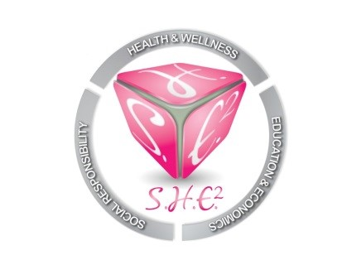
MEETING MINUTES, July 17, 2018
- Introduction of members
Attendance: Carlis Lollie, Dr. Jeffea Gullett, Lashandra Boddy

- Old Business
- Please submit headshot and brief bio to be added to website. A headshot photo shoot is forthcoming. In the meantime, please send an appropriate headshot.
- The last scholarship that was received on behalf of S.H.E. Squared was the TXSU Motion Alumni scholarship for current majorettes. $250 was given to (2) current members.
- New Business
- 80’s Rock Brunch- We need to sale a minimum of (25) tickets to have the event. It was proposed to not cancel the event, but to continue with the event. Board members should help contribute to the event so that the organization can stay afloat and have funds available to pay for needed items. It was voted and agreed that each board member will pay $25 per month to S.H.E. Squared, which is tax deductible ($300/year).
-Lashandra will organize games at the even to include: “80’s Best Dressed”, Shazam and hula hoop contest.
-Jeffea will organize (3) gifts for contest winners.
-Carlis will handle logistics, catering
-Attendees will receive a brunch plate worth no more than $10 and (1) complimentary mimosa.
-Each board member is responsible for purchasing a ticket to the event.
B. Scholarship Gala
-November 4, 2018 at the John P. McGovern Health Museum from 6-10PM. It was discussed that 6-10PM is too late on a Sunday for the event, so we will have to really promote the event.
-There may be difficulty getting local TV personalities to host the event due to their schedules being booked a year in advance. Lashandra will work on getting a local host.
-It was discussed that the DJ should fill up most of the entertainment time at the event. The program shouldn’t be too full.
- NEEDS: Caterer, DJ, Host, Guest Speakers, Sponsors, Ticket Sales
C. Grants
-S.H.E. Squared will collaborate with grant writers to assist with writing grants. Lashandra will assist with finding grant writers to help the organization.
D. Community Service - S.H.E. squared ill partner with the Houston Area Women’s Center to adopt a family for Christmas. Details are forthcoming.
E. Fundraising- S.H.E. Squared will host a “Boo Bash” Halloween costume party. Date/Time/Location/TBA.
IV. Planning
-S.H.E. Squared will meet in January to plan the 2019-2022 initiatives based on the (4) targets of the organization: Social Responsibility, Health and wellness, Education and Economics.

