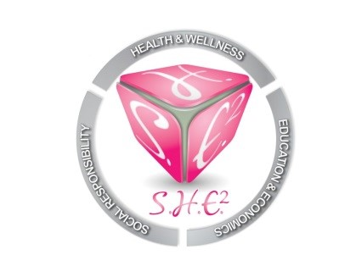
CONFERENCE CALL MINUTES
September 9, 2018
6:30PM-6:53PM
Our mission is to empower and motivate women of all ages and backgrounds in the areas of Social responsibility, Health and wellness, Education and Economics. S.H.E. Squared will provide workshops, seminars, scholarships and community support to individuals and organizations that are either female driven or geared towards the advancement of women.

Call Time: 23 minutes

Present on the call:
Carlis Lollie
Yolanda Brown
Erin Moseley
Jeffea Gullett

Excused: Latonia Fannin, Lashandra Boddy

I. Laptop Giveaway
Lead: Erin Mosley

Laptops will be donated to the Imani School. The donation drop off date will be on a day during the week between 4-6PM. This is a good time for photos and publicity. Board members are asked to be in attendance wearing S.H.E. Squared t-shirts. A specific day and time is TBA.

II. Halloween Party
Lead: Erin Mosely

-Halloween event will be, Friday, October 26th.
-Draft for treatment is ready and will be emailed soon.
-Help is needed securing a venue. “Level Chic” and (2) other venues were mentioned as possible locations.
-Board members must identify a budget for the event.

III. Nursing Scholarship Cocktail Fundraiser
Lead: Carlis Lollie

-The event is postponed and renamed “Nurses Night & The Museum”. The event is slated to take place during Nurses Week 2019 at the John P. McGovern Health Museum on May 9th.
-Liquor/Bar sponsor has been identified.
-Needs: Guest Speaker, Food sponsors, Sponsorships, Activities.
-Once new packets are completed a general meeting will take place with all parties involved.

IV. Christmas Party
Lead: Jeffea Gullett

-Date is December 15th weekend
-Star of Hope wanted to select a homeless family and have volunteers provide items on their Christmas list. The items will be given to the parents and the parents will give the toys to the children. The Board decided that they wanted to do something more personal so we can interact with the families. The Board chose the Houston Area Women’s Center (HAWC). We will host a discreet party for the selected family. HAWC is focusing on Thanksgiving at the moment and will start coordinating Christmas activities after November.

V. Dues are $25/per month. Dues are due for July and August. Dues payments can be made via the organization website in the members only section. There is a single payment and recurring payment option.

